Curriculum Vitae
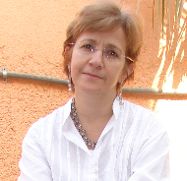

Gul Menet Kirmizi – Hatko Marshan Ceka (MFA, DEU)

Address:
---------------------------------------------------------------------------------------------------------------------

Talatpaşa Cad. Nur Ap. No: 41/17, 35220, Alsancak, Izmir / Turkey

Tel: (90) 232 464 12 25 (Home Phone & Fax),
---------------------------------------------------------------------------------------------------------------------

E.mail: gulmenet@gmail.com

PERSONAL DETAILS

Full name: Gul Menet Kirmizi – Hatko Marshan Ceka
Nationality: Turkish and Albanian citizen
DOB: 06 / 03 / 1960
Marital status: Married with one son
Gender: Female

Educations

İzmir Dokuz Eylul University (DEU)-Turkey

Faculty of Fine Arts- Department of Textile and Fashion Design

Graduation: Bachelors Degree
Graduation points : 3.22 (First out of 40 Students in Department of Textile and Fashion Design)
Specialized in Textile Design, mainly covering below given research areas
Textile Technologies, Screen Printing, Drawing,Weaving, Embroidery, Felt Making , Fashion, Home Textiles & Interior Design

İzmir Dokuz Eylul University (DEU) -Turkey

The Institute of Fine Arts
Textile Design Department

Graduation: Textile Technology / Master Degree
Graduation points: 3,23
Specialized in Textile Technology, mainly covering below given research areas
Textile Technology in general, Computer Aided Fashion & Interior Design, Clothing Design, Contemporary Art Movements and Textile Design, Fabric Patterns Design, Form and 3D Design, Product Development in Clothing Design, Design and Product Development for Home Textiles & Interior Design

Graduation

Anatolian University Justice College

Languages

English (Excellent), Arabic (Fair)

Professional Activities

Employer: INSMAK / Incorporate Company., İzmir, Turkey

Executive Secretary (1979 – 1981)

Employer: H.R.H. Al-Bandari Bint Khalid Bin Abd al-Aziz Al Saud / Riyadh, Kingdom Of Saudi Arabia

Palace Manager & Curator of Art Collections (1996-1998)

Employer: FAISAL ABDULHAMEED AL-SAADAWI ESTABLISHMENT FOR TRADING

Projects Manager (Turkey and Saudi Branches) (1998 – 2011)
Arts and Antiques
P.O.Box 56677
Riyadh 11564
Kingdom Of Saudi Arabia

Responsibilities:
- Projects Manager
- Chief interior designer and senior textile designer.
- Sales and relations with other companies on local and international levels
- Setting trends through design and development.
- Updating design ideas and trends.
- Deciding on specifications that reflect creative, cohesive collections.
- Communication with product managers on a regular basis about specifications, Interior Design Projects, home textiles and details for all product categories.
- Research on updates and development of projects, prints and patterns with fabric team and CAD designers.
- International communications, curator of art collections
- Writing legal documents of contracts for the productions of Interior Design Projects, haute couture textiles installations.

Employer Polis University
Faculty of Architecture and Art Design

Invited Professor (2011 – 2013)

St."Highway Tirana-Durrës", Km 5th, Kashar, Tiranë Albania
Tel: +355.(0)4.2407420 / +355.(0)4.2407421
Fax:+355. (0)4.2407422
Mob:+355 (0) 69 40 88 111
Website: www.universitetipolis.edu.al

Extra Curricular Studies

Training Courses
BUCA / Wool Textile İndustry and Trading İncorporate Company, Buca – İzmir, Weaving course 2001
AYDINEL / Textile İndustry and Trading İncorporate Company, Cigli– İzmir, 2002- Fashion course
İZMİR / Cotton İndustry and Trading İncorporate Company. İzmir, Printing course 2004

Seminars
Title: “Contemporary Art Movements from the Industrial Revolution Era to Date”,
Dokuz Eylul University Conference Hall, Izmir, Turkey, December, 2006
Title: “Textile History – From Prehistoria to Date”,
Dokuz Eylul University Conference Hall, Izmir Turkey, April, 2007
Workshops
‘’ Shibori Workshop’’ (Japanese Textıle Dyeing Technıque)
Visions in Textiles” 13 th. ETN International Textile Conference, Exhibition and Workshop held by Textile and Fashion Design Department in cooperation with ETN (European Textile Network), İzmir, Turkey, September 2005.

Exhibitions
Group Exhibitıons
Photography exhibition
Dokuz Eylul University Exhibition Hall December 2001 İzmir –Turkey
Textile printing exhibition
Dokuz Eylul University Exhibition Hall May 2002 İzmir- Turkey

Solo Exhibitions
Textile printing exhibition
Sponsored by the Ministry of Culture and Tourism, Turkey,
State Exhibition Hall, Izmir, April 2002 İzmir -Turkey

Awards
Taç Linen – ‘’Zorlu’’ Textile Corporate; Mehmet Zorlu Foundation “Special Prize”
January 2004 İstanbul / Turkey

Hobbies
Scuba Diving - PADI Certification - U.S.A.
Tennis
Horse-riding

Diplomas:
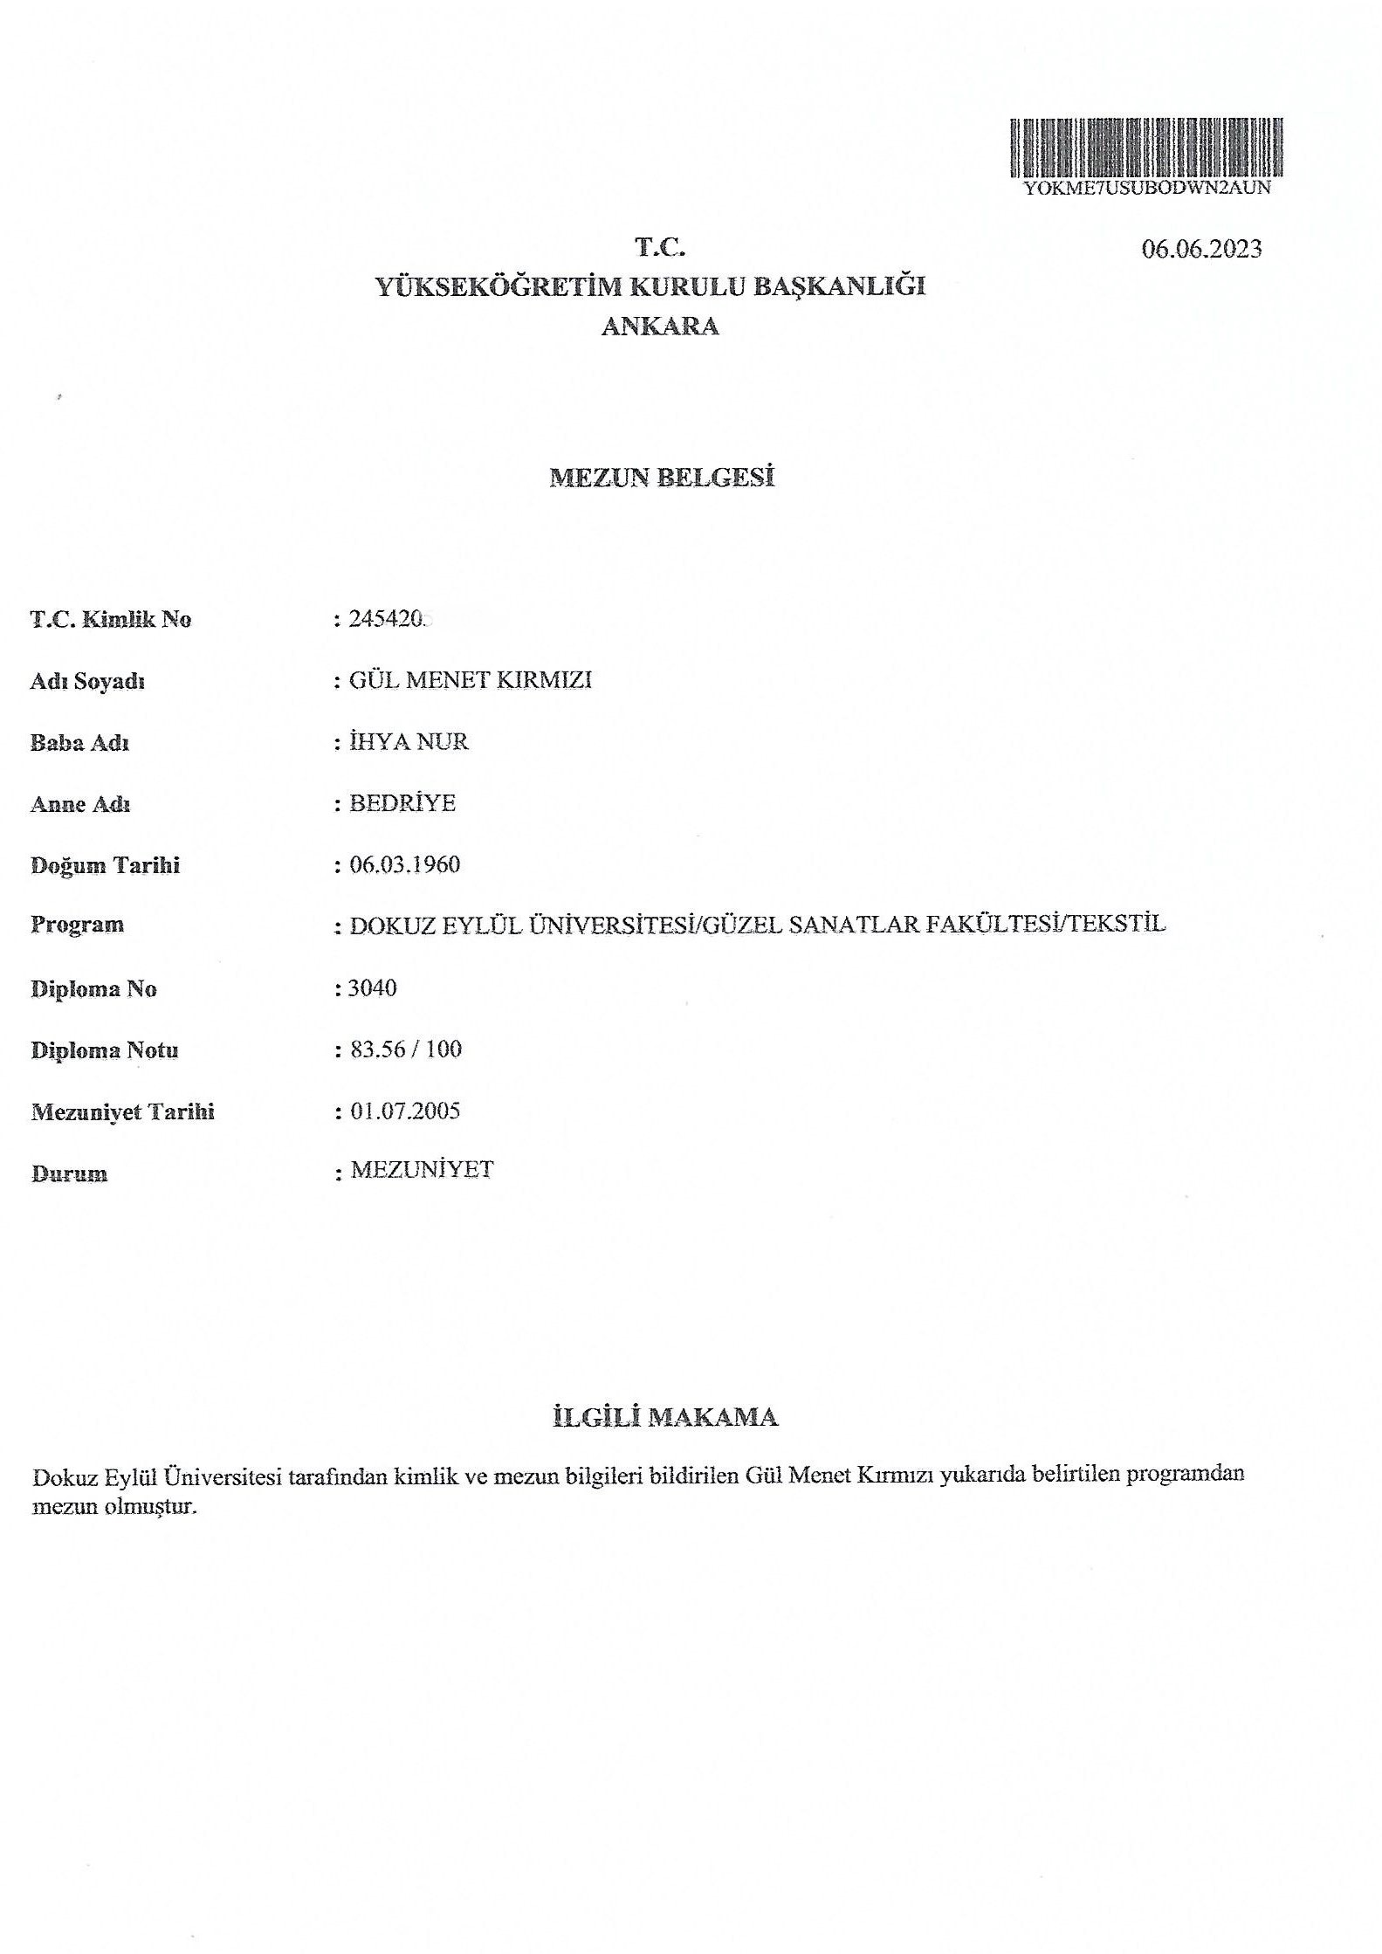 |  | 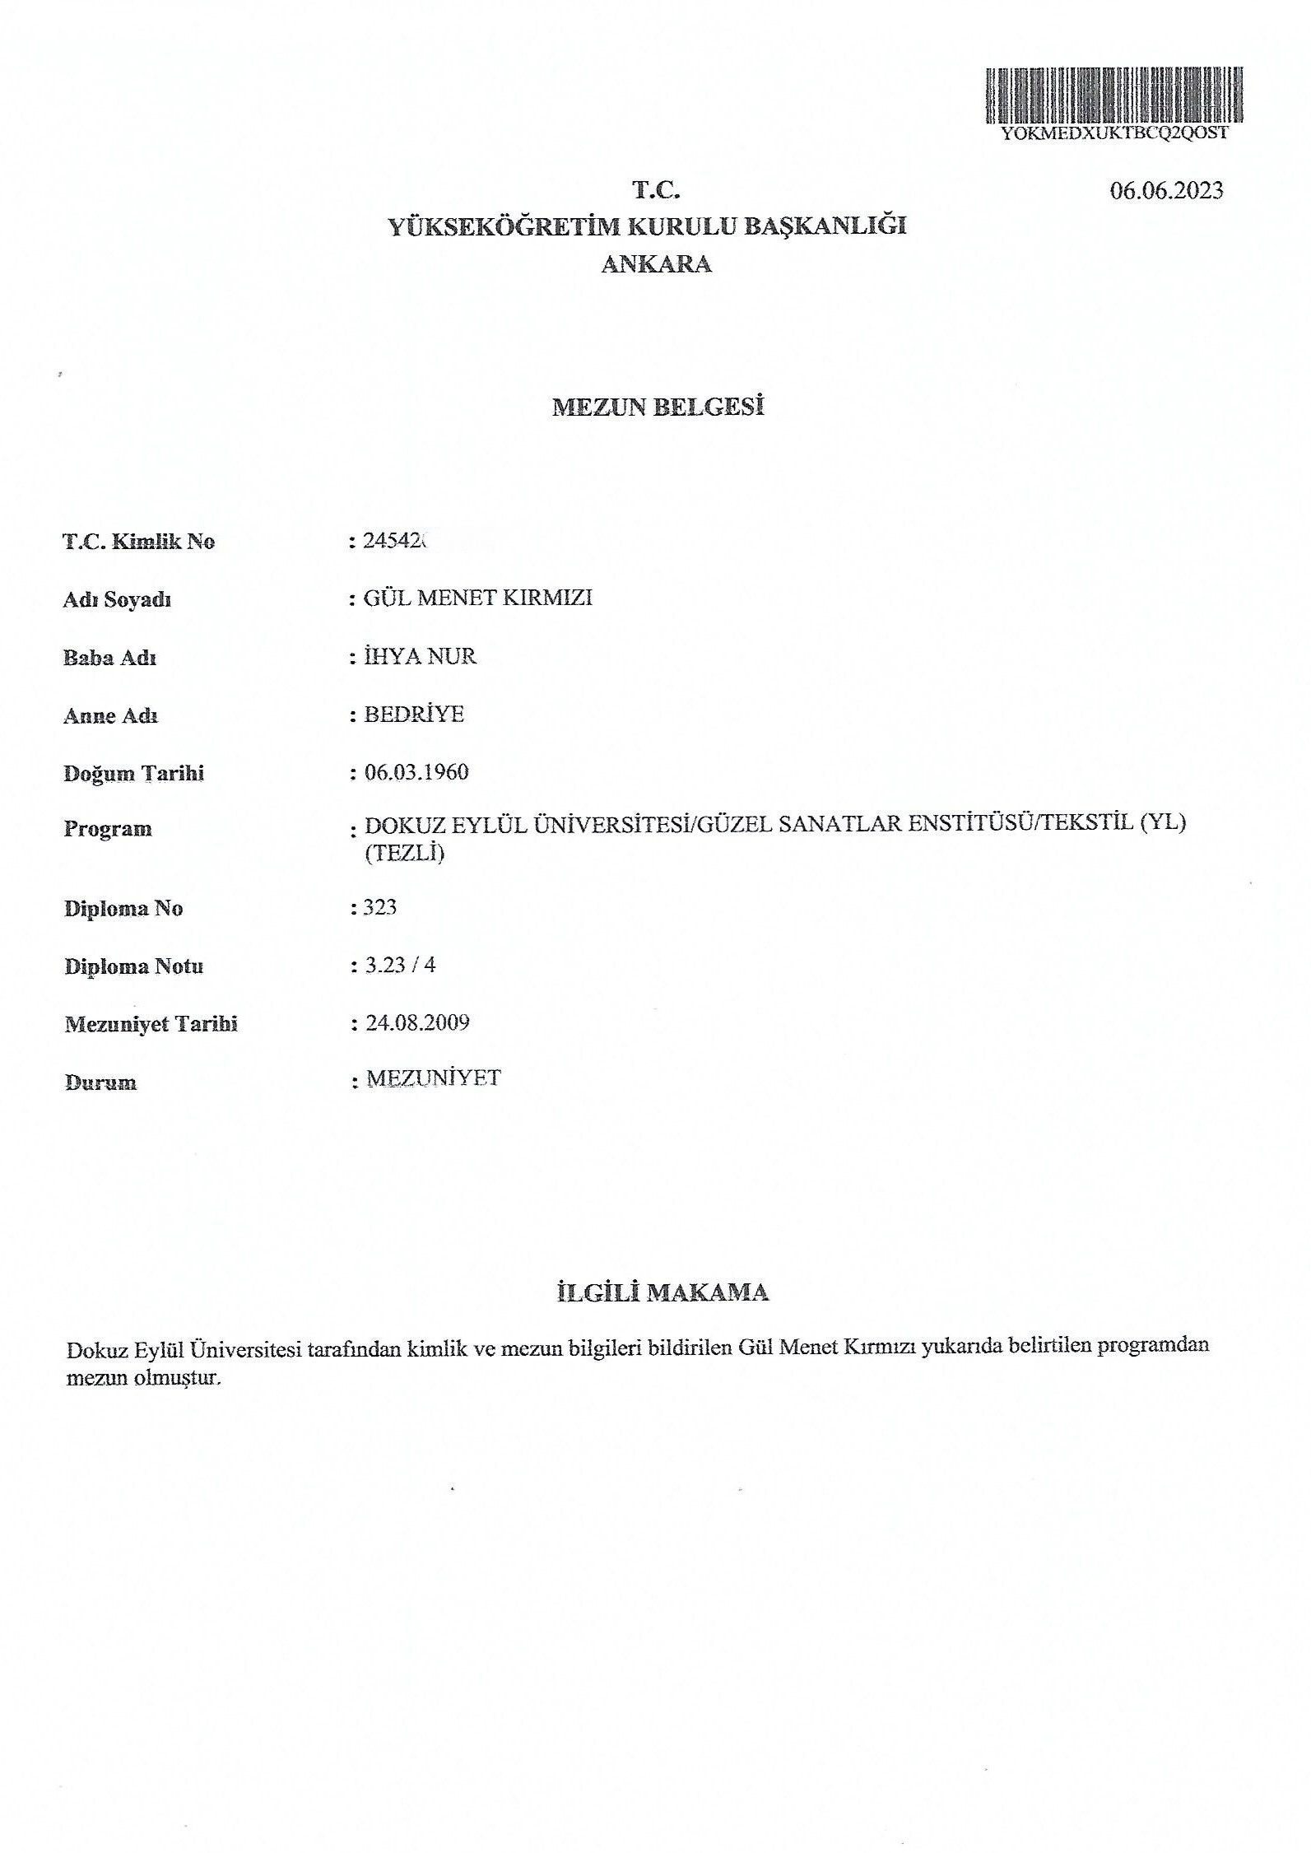 |  | 